Chapter 17, Solution 30.

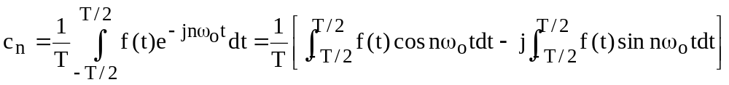 (1)

(a) The second term on the right hand side vanishes if f(t) is even. Hence

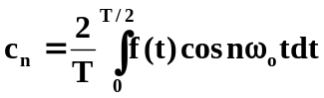

(b) The first term on the right hand side of (1) vanishes if f(t) is odd. Hence,

